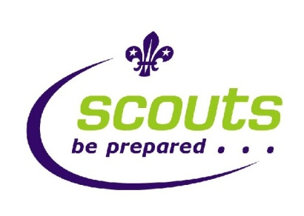
2nd Rugeley Scout Group
Registered Charity No. 1111375

March 2012
Dear Parent/Guardian,
I would like to make you aware of our website that is currently under development, at www.2ndrugeleyscoutgroup.com. The site contains useful information for beavers, cubs and scouts; including latest news, frequently asked questions, and details on the uniform and where badges should be attached. Letters to parents/guardians will be archived on the site, to access electronically. There is also a section about our Sheepfair Community Centre, with details on how to hire rooms and book events.
A main feature of the site is the photo gallery. This contains images of children from all three sections, showcasing the various activities we provide for them. Whilst we feel that the gallery is great way for you to see what your child gets up to in scouting, and to publicise our group, we recognise that the publication of a child’s image on the internet is a sensitive issue. Therefore, attached with this letter is an Image Consent Form. This gives you the opportunity to withdraw your consent for us to use your child’s image either online or in print, should you wish to do so.
We hope you enjoy the website and find the information useful.
Yours in Scouting,

Simon Hodgkinson
Publicity Co-Ordinater
Assistant Cub Scout Leader

